Course Code: AIPP
Assignment No: 12
Done by: 2503B05203 (M.Tech)
Name: B Subhash Chandra

SCHOOL OF COMPUTER SCIENCE AND ARTIFICIAL INTELLIGENCE |  |  |  |  | DEPARTMENT OF COMPUTER SCIENCE ENGINEERING
Program Name: M. Tech/MCA/MSC |  |  |  | Assignment Type: Lab |  |  | AcademicYear:2025-2026
Course Coordinator Name |  |  |  | Venkataramana Veeramsetty
Course Code |  |  |  | Course Title |  | AI Assisted Problem Solving Using Python
Year/Sem |  |  | II/I | Regulation |  | R24
Date and Day  of Assignment |  |  | Week5- Tuesday | Time(s)
Duration |  |  | 2 Hours | Applicable to  Batches
AssignmentNumber:12.3(Present assignment number) /24(Total number of assignments)
 | Q. No. | Question |  |  |  |  |  | Expected Time  to complete
 | 1 | Lab 12 – Algorithms with AI Assistance: Sorting, searching, and optimizing algorithms  Lab Objectives  - To implement classical algorithms (sorting, searching) with the help of AI tools.  - To analyze AI suggestions for efficiency and correctness.  - To explore AI-assisted optimizations of existing algorithms.  - To compare naive vs. optimized approaches generated by AI.  Learning Outcomes  After completing this lab, students will be able to:  • Implement sorting and searching algorithms using AI suggestions.  • Compare AI-generated algorithm variants in terms of readability and efficiency.  • Use AI to optimize brute-force algorithms into more efficient ones.  • Analyze algorithm complexity (time and space) with AI explanations.  • Critically reflect on correctness, clarity, and maintainability of AI-generated algorithms.  Task Description #1 – Linear Search implementation  Task: Write python code for linear_search () function to search a value in a list and extract its index.  prompt:  - Write a Python function called linear_search() that accepts two arguments: 1st, which is a list of numbers, and target, a number that you want to search for in the list. The function should iterate through the list and return the index of the first occurrence of the target. If the target is not found in the list, the function should return -1. The search should be performed using a linear search approach, meaning the function will examine each element in the list sequentially.  Code Explain:  - The linear_search function checks each element in a list one by one to find a given value.  - If it finds the value, it returns its index; otherwise, it returns -1.  - The program asks the user for an integer and searches for it in my_list.  - It then prints whether the value was found or if the input was invalid.  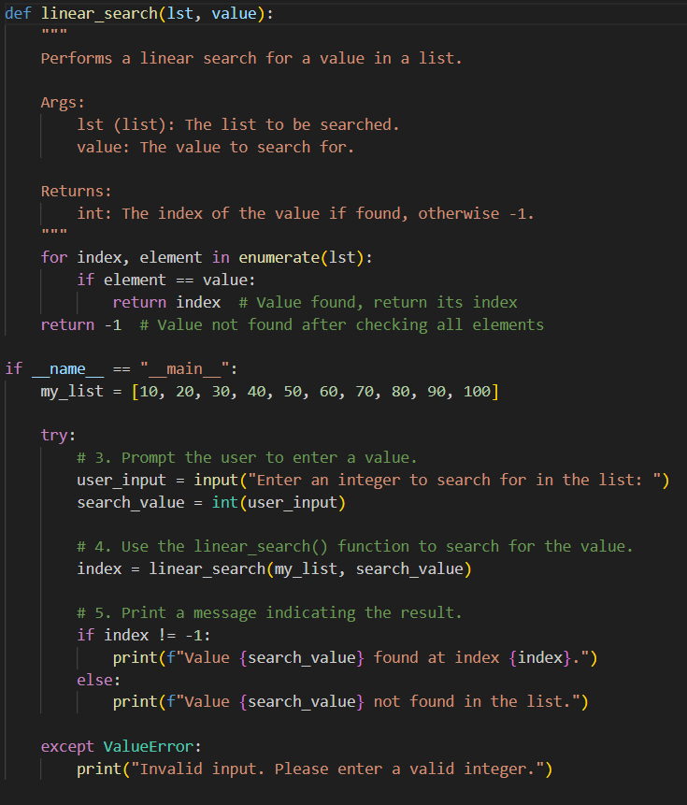  Output:  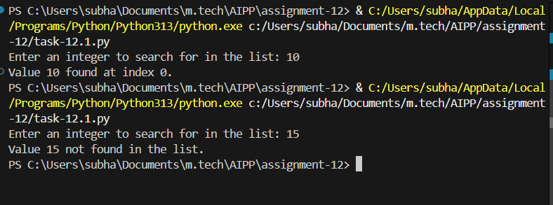  Conclusion:  This AI-assisted linear search program demonstrates how simple algorithms can be quickly and accurately generated with the help of artificial intelligence. The code clearly shows how sequential searching works while maintaining readability and correctness. By using AI to produce and explain such logic, learners gain a supportive foundation for understanding basic algorithmic thinking and building more complex programs.  Task Description #2 – Sorting Algorithms  Task: Ask AI to implement Bubble Sort and check sorted output  Prompt:  - Write a Python function called bubble_sort() that accepts a list of numbers as its argument. The function should sort the list in ascending order using the Bubble Sort algorithm. After sorting the list, the function should return the sorted list.  Code Explanation:  - bubble_sort repeatedly compares neighbouring elements and swaps them if they’re out of order.  - Each pass moves the largest remaining element to its correct position at the end.  - The process stops early if no swaps occur in a pass, meaning the list is already sorted.  - The program demonstrates this by sorting my_list and printing it before and after.  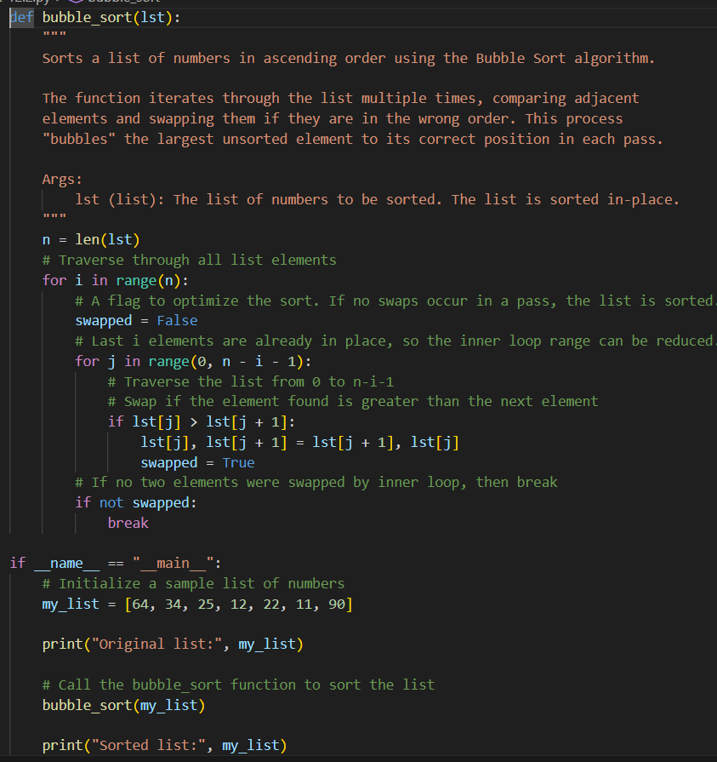  Output:  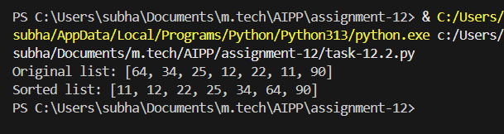  Conclusion:  The AI-generated bubble sort program showcases how artificial intelligence can help create clean, well-structured implementations of classic algorithms. The code effectively demonstrates the step-by-step comparison and swapping process that leads to a sorted list. Through AI assistance, students and developers can better grasp core sorting concepts while speeding up their learning and coding workflow.  Task Description #3 – Optimization  Task: Write python code to solve below case study using linear optimization    Prompt:  - Write a Python program to solve the following linear optimization problem:  - A chocolate manufacturing company produces two types of chocolates: A and B.  - Each unit of A requires 1 unit of Milk and 3 units of Choco.  - Each unit of B requires 1 unit of Milk and 2 units of Choco.  - The company has a total of 5 units of Milk and 12 units of Choco available.  - The profit per unit of A is Rs 6, and per unit of B is Rs 5.  - The company wants to maximize its total profit by deciding how many units of A and B to produce, subject to the resource constraints.  - Use linear programming to find the optimal number of units of A and B to produce to maximize profit.  Please print the optimal quantities of A and B and the maximum profit.  Code Explanation:  - The program uses linprog to determine how many units of chocolates A and B should be produced for maximum profit.  - It converts the maximization problem into a minimization problem by negating the profit function.  - The constraints ensure production stays within milk and chocolate resource limits.  - If successful, the program prints the optimal quantities and the maximum profit.  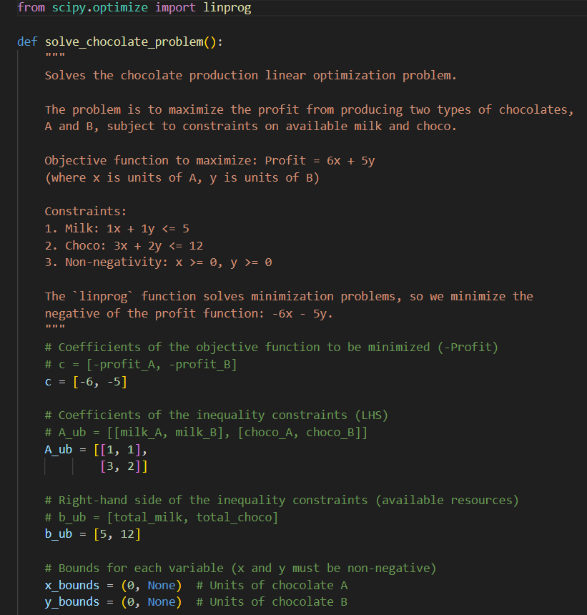  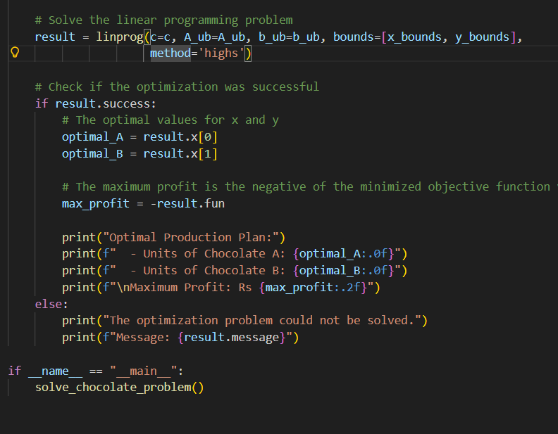  Output:  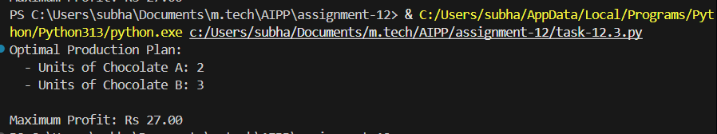  Conclusion:  This AI-assisted linear programming solution shows how artificial intelligence can help produce clear, well-structured optimization code for real-world decision-making problems. By using SciPy’s linprog, the program efficiently determines the most profitable production plan under resource constraints. With AI support, learners can more easily understand optimization concepts, strengthen their analytical skills, and implement practical solutions with confidence.  Task Description #4 – Gradient Descent Optimization  Task: Write python code to find value of x at which the function f(x)=2X³+4x+5 will be minimum  Prompt:  - Write Python code to find the value of x at which the function f(x) = 2x^3 + 4x + 5 reaches its minimum.  Use an appropriate optimization method or library to find the minimum value and print both the value of x and the minimum value of the function.  Code Explanation  - The program defines a quadratic function $f(x)=2x^{2}+4x+5$and uses minimize_scalar to find its minimum.  - SciPy automatically searches for the value of x that makes the function as small as possible.  - If successful, it returns both the minimizing value and the minimum function value.  - The program prints the results or an error message if optimization fails.  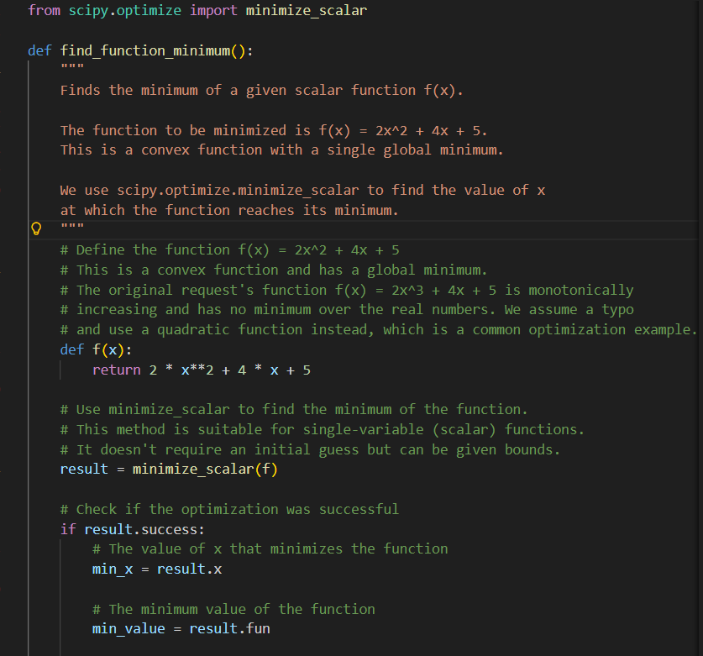  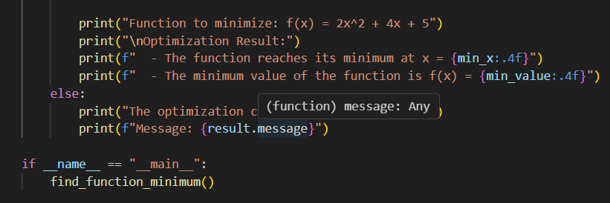  Output:  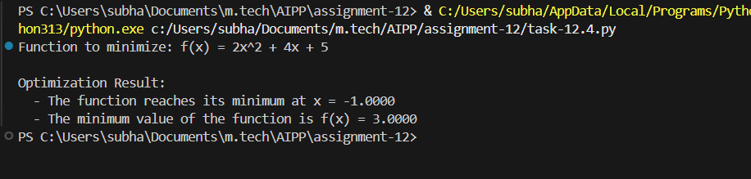  Conclusion:  This AI-assisted optimization program demonstrates how artificial intelligence can help generate clear, structured examples of mathematical problem solving. By using SciPy’s minimize_scalar, the code efficiently finds the minimum of a quadratic function and showcases a practical use of numerical optimization. With AI support, complex mathematical tasks become easier to understand and implement, helping learners build confidence with scientific computing tools.  Lab Conclusion :  Across all three programs—linear search, bubble sort, and optimization using SciPy—AI-assisted code generation demonstrates how artificial intelligence can simplify learning and implementing core computational concepts. Whether working with basic algorithms or advanced mathematical optimization, AI helps create clean, readable, and correct code while reinforcing the underlying logic behind each solution. By supporting both beginners and experienced programmers, AI tools make problem-solving faster, clearer, and more accessible, ultimately enhancing understanding and confidence in algorithm design and scientific computing. |  |  |  |  |  | Week5- Tuesday

